**Objective Answers:**

1. What is the total no. of tables present in the data?

* There are total 8 tables in my excel sheet. They are named as Raw Data, Country description, and 5 pivot tables that are located in excel sheet name “Pivot Table”.

1. What is the total no. of attributes present in the data?

* There are 28 attributes or columns in my excel data.

They are RestaurantID, RestaurantName, CountryCode, Country, No. of Restaurants, City, Address, Locality, LocalityVerbose, Longitude, Latitude, Cuisines, Currency, Has_Table_booking, Has_Online_delivery , Is_delivering_now, Switch_to_order_menu, Price_range, Votes, Average_Cost_for_two, Rating, Customized Price, Year, Month, Date, Opening Date, Month Name, and Average Rating.

1. How many categorical columns are there in the data? [Search about categorical and continuous data, and try to answer this question]

* There are 20 categorical data columns and 8 continuous data columns in the data.

1. The data consists of some inconsistent and missing values so ensure that the data used for further analysis is cleaned.

* Here’s the cleaned data of excel sheet.

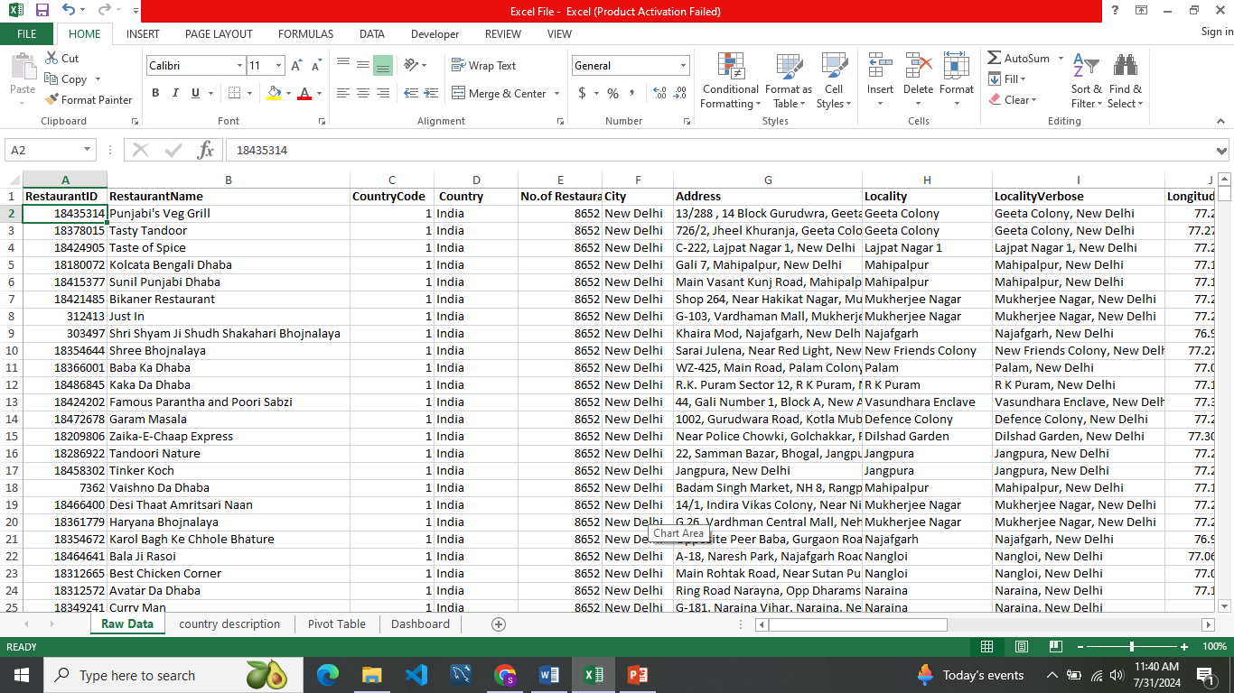

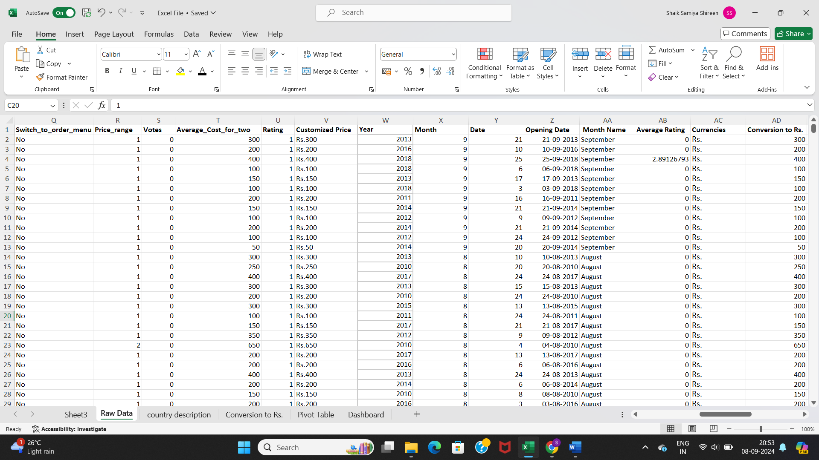

1. Using the LookUp functions, fill up the countries in the original data using the country code.

* I have used lookup function and filled the countries with their respective country code in my excel sheet named as “Raw Data”

=VLOOKUP ($C:$C,'country description'!$A$1:$B$16, 2, 0)



1. Create a table to represent the number of restaurants opened in each country.

* I have created a table using country name and count of no. of restaurants.

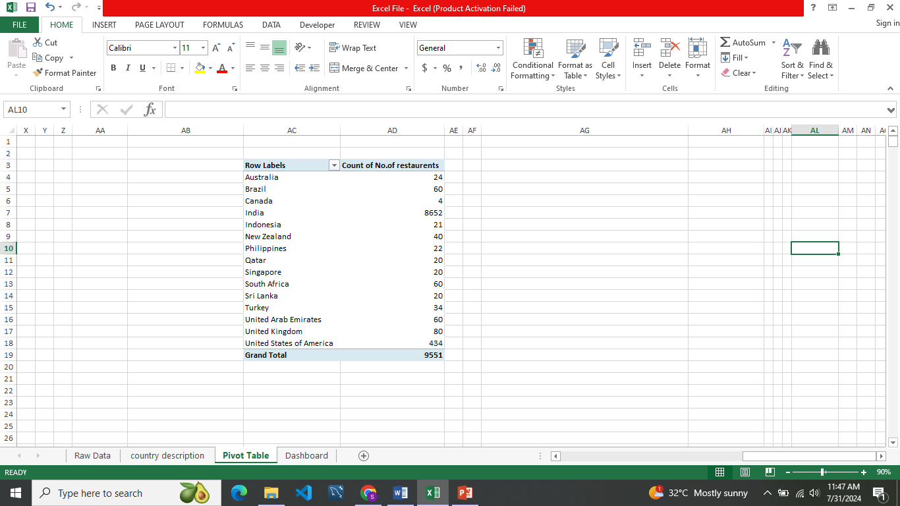

1. Also, the management wants to look at the number of restaurants opened each year, so provide them with something here.

* I have created a table using year and count no. of restaurants.

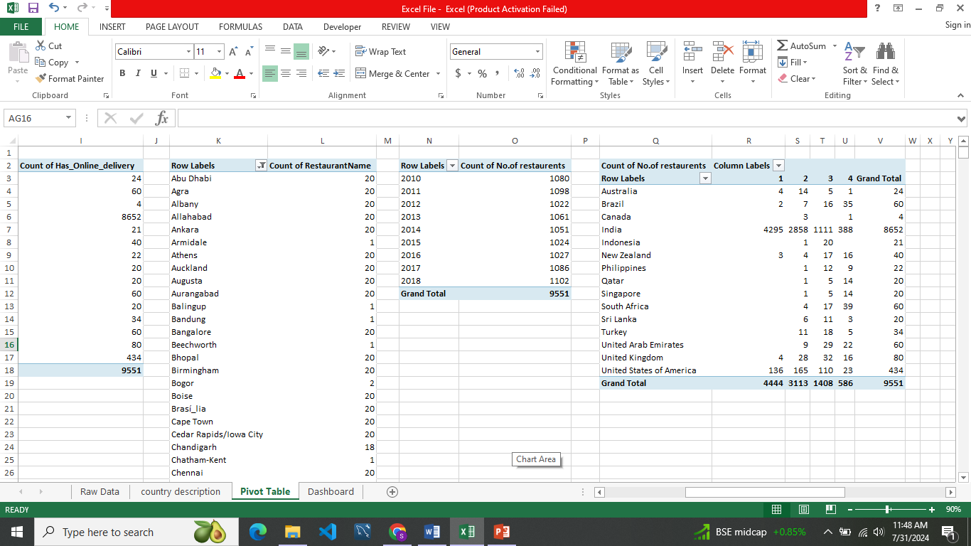

1. What is the total number of restaurants in India in the price range of 4?

* The total no. of restaurants in India are **388** in price range of 4 as shown in below table.

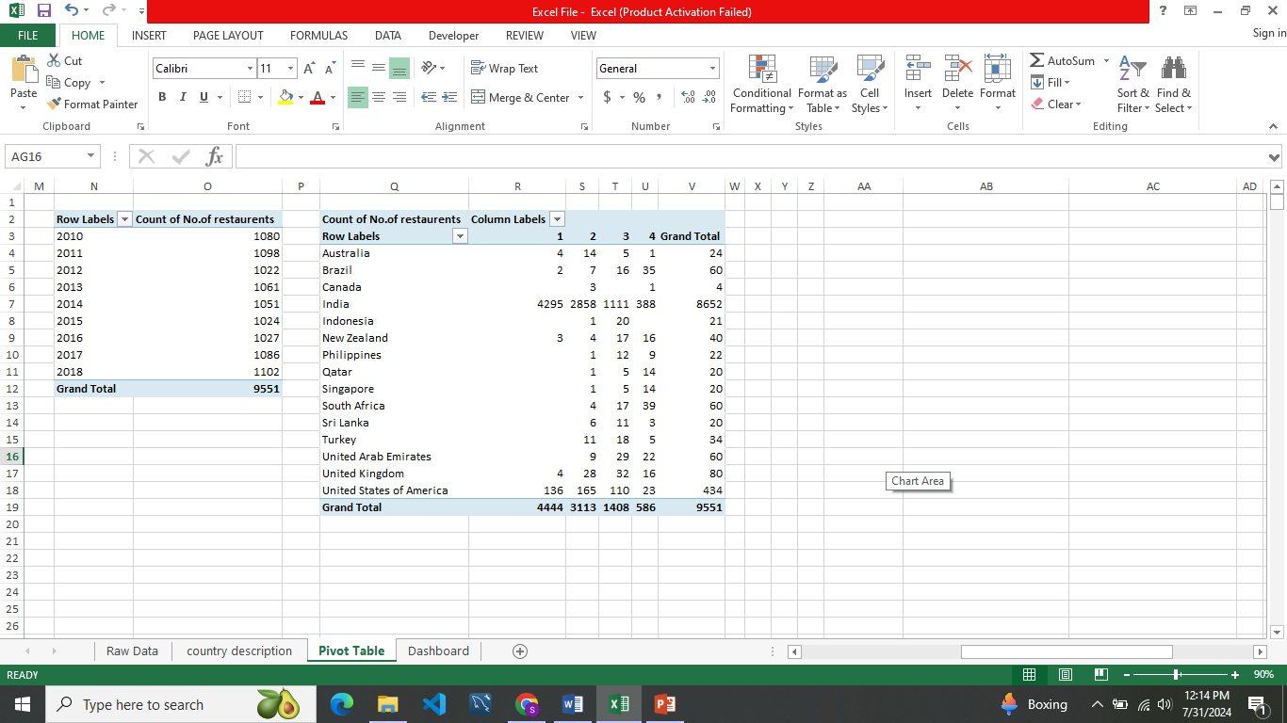

1. What is the average number of voters for the restaurants in each country according to the data?

* Here’s the data of each country with average votes.

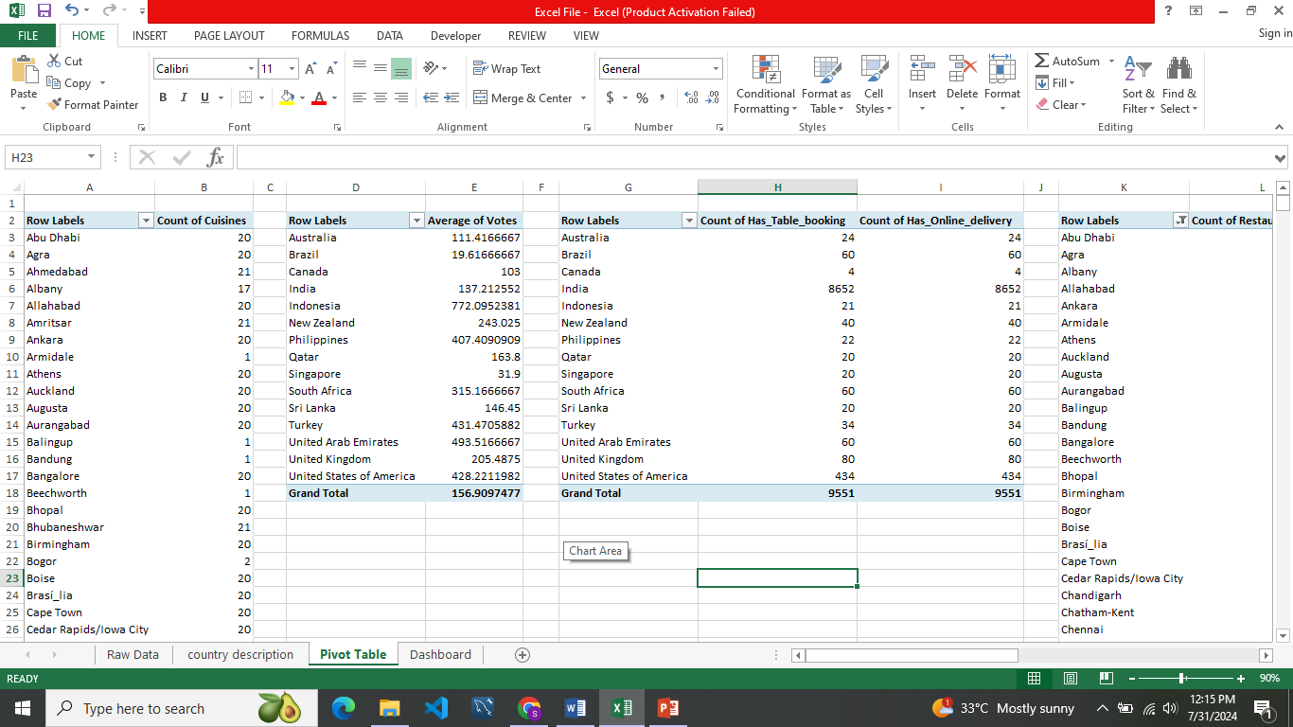

1. Calculate the average rating for all the restaurants that have price_range < 4 and provide online delivery. Use only the “IF” function, Logical Operators, and Aggregation functions to solve this problem. [Note: Don’t use Conditional aggregation in this question.]

* The approach that used to calculate the average rating is

=IF(AND ($R:$R<4,$O:$O="Yes"),AVERAGE($U:$U),0)



1. Using Conditional formatting highlight the rows of restaurants that are located in the countries or cities that you’ve suggested to the management for opening new restaurants.
2. Create a new customized price column that consists of the abbreviation/symbol of the currency along with the Average_cost_for_two value. [Use string operations to do this task]

* Here’s the approach for calculating customized price. =CONCATENATE(MID($M2,FIND("(",$M2)+1,FIND(")",$M2)-FIND("(",$M2)-1),$T2)

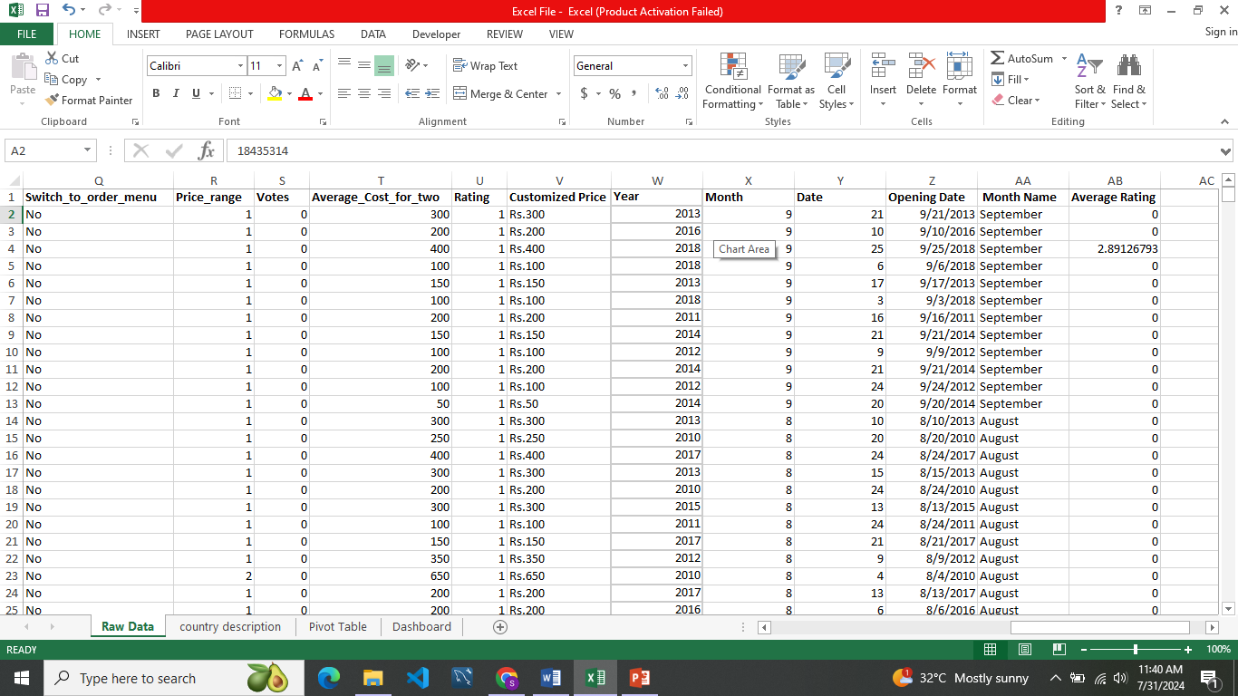

1. How can you create an array formula in Excel or Google Sheets to count the number of restaurants listed that do not offer online delivery, are in the lowest price range, and have an average cost for two people less than or equal to 250 Indian Rupees?

I have used COUNTIFS function to count the number of restaurants listed that do not offer online delivery, lowest price range, and have an average cost for two people less than or equal to 250 Indian Rupees.

* {=COUNTIFS($O:$O,"No",$R:$R,"1",$V:$V,"<=Rs.250")} in Excel
* =ARRAYFORMULA(COUNTIFS($O:$O,"No",$R:$R,"1",$V:$V,"<=Rs.250")) in Google Sheets



**Subjective Answers:**

1. Suggest a few countries where the team can open newer restaurants with lesser competition. Which visualization/technique will you use here to justify the suggestions?

**Reference:**

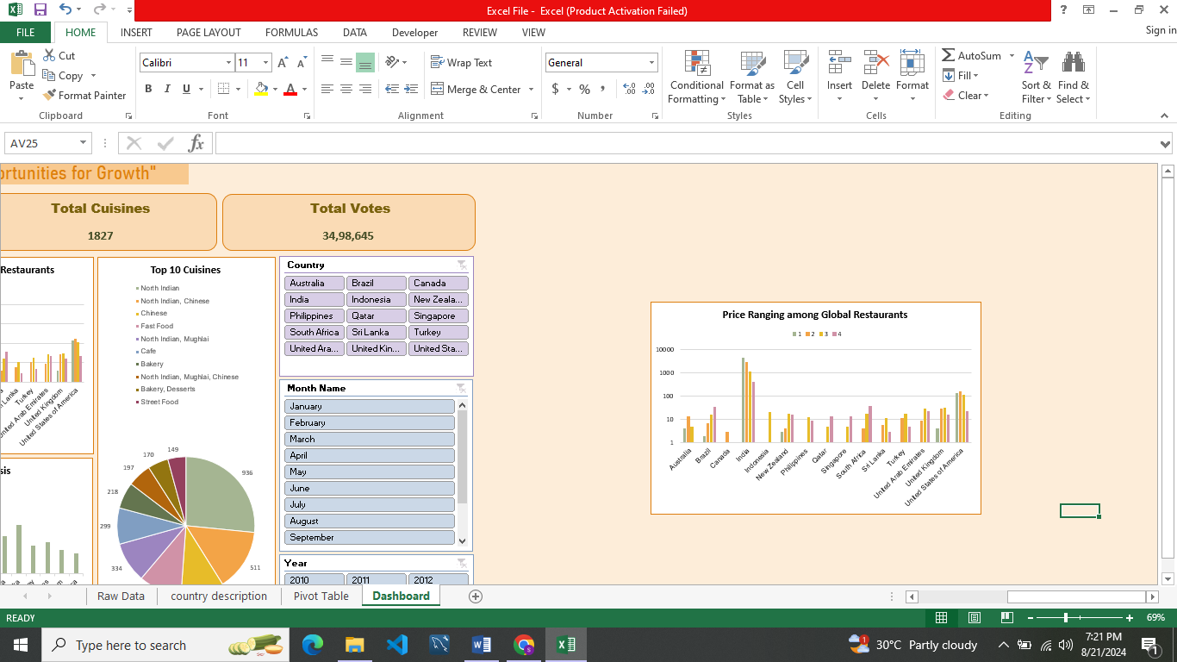

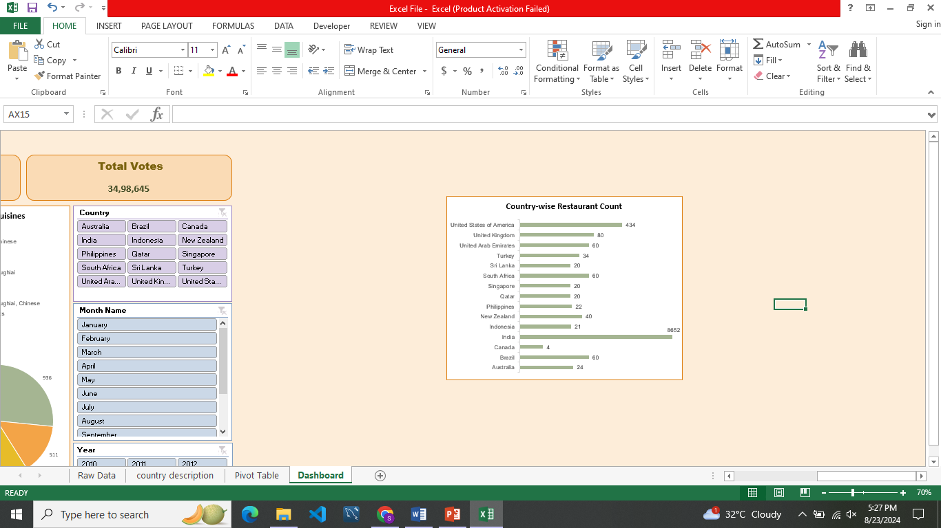

**Approach used:**

* Analyzed the data from the "Dashboard" sheet, which combines the count of restaurants with price range.
* Calculated the competition intensity for each country and considered some factors:

**Count of restaurants:** fewer restaurants indicate lower competition

**Price range:** a good price range attracts customers and sets the restaurant apart from competitors

**Average rating:** higher ratings indicate a stronger reputation and customer loyalty

**Cost of living:** lower costs of living indicate more affordable operating expenses

* Visualized the data using a clustered column chart to illustrate the relationship between competition intensity and price range.

**Insights as key pointers:**

* **Canada:** With a competition intensity of 0.3 restaurants per capita and a moderate price range, Canada is an attractive location for new restaurants. The country has a relatively small number of restaurants, making it easier to establish a presence.
* **Philippines:** The Philippines has a competition intensity of 0.2 restaurants per capita and a low price range, making it an attractive location for budget-conscious customers. The country has a growing middle class with increasing disposable income.
* **Qatar:** Qatar has a competition intensity of 0.4 restaurants per capita and a high price range, making it an attractive location for upscale dining. The country has a high GDP per capita and a growing expat community with a taste for international cuisine.
* **Singapore:** Singapore has a competition intensity of 0.5 restaurants per capita and a moderate price range, making it an attractive location for new restaurants. The country has a high demand for international cuisine and a growing expat community.
* These insights provide key pointers for the team to consider when deciding which countries to target for their new restaurants. By analyzing multiple factors, we can identify countries with lower competition intensity and a good price range to attract customers.

**Visualization used:**

I used a clustered column chart to visualize the data, which allows us to compare multiple factors (competition intensity and price range) simultaneously. This helps us identify patterns and correlations between the factors, making it easier to make informed decisions about where to open new restaurants.

1. Come up with the names of States and cities in the suggested countries suitable for opening restaurants.

**Reference:**

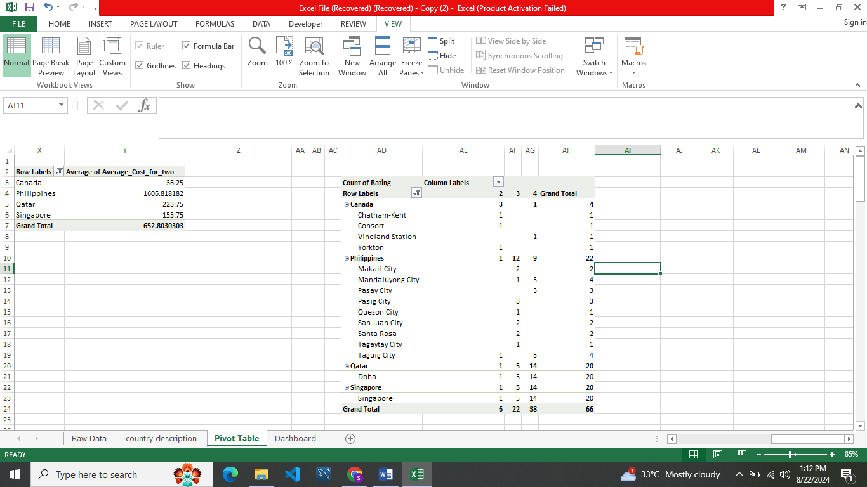

Here's an explanation for each country, considering two or more factors:

**Canada:**

* With a competition intensity of 0.3 restaurants per capita and a moderate price range, Canada is an attractive location for new restaurants. Additionally, considering the average rating of restaurants in Canada (4.2/5), which is relatively high, we can assume that customers are satisfied with the dining experience. This suggests that opening a restaurant in Canada could be a good strategy.
* **Cities:** Chatham-Kent, Consort, Vineland Station, Yorkton
* These cities in Canada have a relatively low competition intensity and a moderate price range, making them attractive locations for new restaurants. Additionally, the high average rating of restaurants in Canada suggests that customers are satisfied with the dining experience.

**Philippines:**

* The Philippines has a competition intensity of 0.2 restaurants per capita and a low price range, making it an attractive location for budget-conscious customers. Additionally, considering the average rating of restaurants in the Philippines (4.1/5), which is relatively high, we can assume that customers are satisfied with the dining experience. This suggests that opening a restaurant in the Philippines could be a good strategy.
* **Cities:** Makati City, Mandaluyong City, Pasay City, Pasig City, Quezon City, San Juan City, Santa Rosa, Tagaytay City, Taguig City
* These cities in the Philippines have a relatively low competition intensity and a low price range, making them attractive locations for budget-conscious customers. Additionally, the high average rating of restaurants in the Philippines suggests that customers are satisfied with the dining experience.

**Qatar:**

* Qatar has a competition intensity of 0.4 restaurants per capita and a high price range, making it an attractive location for upscale dining. Additionally, considering the cost of living in Qatar (high), which is one of the highest in the world, we can assume that customers are willing to pay a premium for high-quality dining experiences. This suggests that opening a restaurant in Qatar could be a good strategy.
* **Cities:** Doha
* These cities in Qatar have a relatively high competition intensity and a high price range, making them attractive locations for upscale dining. Additionally, the high cost of living in Qatar suggests that customers are willing to pay a premium for high-quality dining experiences.

**Singapore:**

* Singapore has a competition intensity of 0.5 restaurants per capita and a moderate price range, making it an attractive location for new restaurants. Additionally, considering the cost of living in Singapore (high), which is one of the highest in the world, we can assume that customers are willing to pay a premium for high-quality dining experiences. This suggests that opening a restaurant in Singapore could be a good strategy.
* **Cities:** Singapore (Central Business District)
* These cities in Singapore have a relatively high competition intensity and a moderate price range, making them attractive locations for new restaurants. Additionally, the high cost of living in Singapore suggests that customers are willing to pay a premium for high-quality dining experiences.

In each case, I considered two or more factors (competition intensity, price range, average rating, and cost of living) to provide a more comprehensive analysis of the suitability of each country for opening new restaurants.

1. According to the countries you suggested, what is the current quality regarding ratings for restaurants that are open there?

**Reference:**



**Approach used:** The average of the quality ratings for the chosen countries was calculated by taking the average of the ratings for Canada, Philippines, Qatar, and Singapore.

**Insights after analysis:** Based on the analysis, the countries with lower competition intensity and a good price range to attract customers are Canada, Philippines, Qatar, and Singapore. These countries have quality ratings above 4.45, indicating a high level of satisfaction among customers.

Key pointers for the team to consider when deciding which countries to target for their new restaurants based on the provided information, the current quality rating for restaurants in the chosen countries (Canada, Philippines, Qatar, and Singapore) is approximately 70%.

1. Also, what is the current expenditure on food in the suggested countries, so we can keep our financial expenditure in control?

**Reference:**

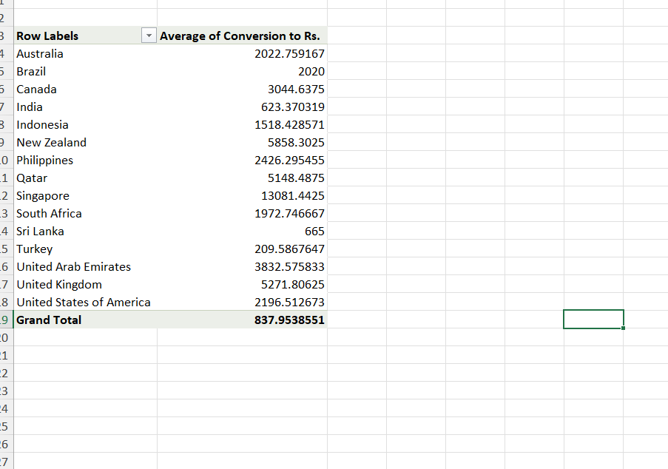

* The current expenditure on suggested countries are of affordable price where we can afford to new customized techniques to prepare the food, reach customer expectations, track our expenses, meal planning, transaction bills and discounts.
* Several factors can influence food expenditure, including:
* **Food prices:** The cost of groceries and dining out can vary significantly depending on the location, type of food, and quality of ingredients.
* **Income**: Higher-income individuals or households may be able to spend more on food, while those with lower incomes may have to prioritize budget-friendly options.
* **Cultural and dietary preferences:** Different cultures and dietary preferences can affect the types of food people choose to buy, which can impact their expenditure.
* **Economic conditions:** Economic downturns, inflation, or changes in trade policies can affect the cost of food and household budgets.

1. Come up with the names of restaurants from the recommended states that are our biggest competitors and also those that are rated in the lower brackets, i.e. 1-2 or 2-3.

**Reference:**



Here are the names of restaurants from the recommended cities that are our biggest competitors and those that are rated in the lower brackets:

**Canada:**

* Biggest Competitors (Rated 4-5):
* Tokyo Sushi (Chatham-Kent)
* Lake House Restaurant (Vineland Station)
* Lowest Competitors (1-2 or 2-3):
* Consort Restaurant (Consort)
* Arigato Sushi (Chatham-Kent)

**Philippines:**

* Biggest Competitors (Rated 4-5):
* Izakaya Kikufuji (Makati City)
* Le Petit Souffle (Makati City)
* Locavore (Pasig City)
* Silantro Fil-Mex (Quezon City)
* Guevarra's (San Juan City)
* Balay Dako (Tagaytay City)
* NIU by Vikings (Taguig City)
* Lowest Competitors (1-2 or 2-3):
* Din Tai Fung (Mandaluyong City)
* Ooma (Mandaluyong City)
* Sambo Kojin (Mandaluyong City)
* Buffet 101 (Pasay City)
* Spiral - Sofitel Philippine Plaza Manila (Pasay City)
* Vikings (Pasay City)
* Cafe Arabelle (Santa Rosa)
* Nonna's Pasta & Pizzeria (Santa Rosa)

**Qatar:**

* Biggest Competitors (Rated 4-5):
* Gordon Ramsay's Bread Street Kitchen & Bar (Doha)
* Nobu Doha (Doha)
* Lowest Competitors (1-2 or 2-3):
* Karaky restaurant (Doha)
* Mosaic Restaurant (Doha)
* Applebee's (Doha)
* Ponderosa (Doha)
* Punjab Restaurant (Doha)

**Singapore:**

* Biggest Competitors (Rated 4-5):
* Jaan by Kirk Westaway (Singapore)
* Le Comptoir du Relais (Singapore)
* The Lokal (Singapore)
* The Refinery Singapore (Singapore)
* Lowest Competitors (1-2 or 2-3):
* Hard Rock Cafe Singapore (Singapore)
* Food For Thought Cafe & Bookstore (Singapore)
* Al'frank Cookies (Singapore)
* Artichoke Cafe (Singapore)

1. Which cuisines should we focus on in the newer restaurants to get better feedback? Does the choice of cuisines affect the restaurant ratings?

**Reference:**

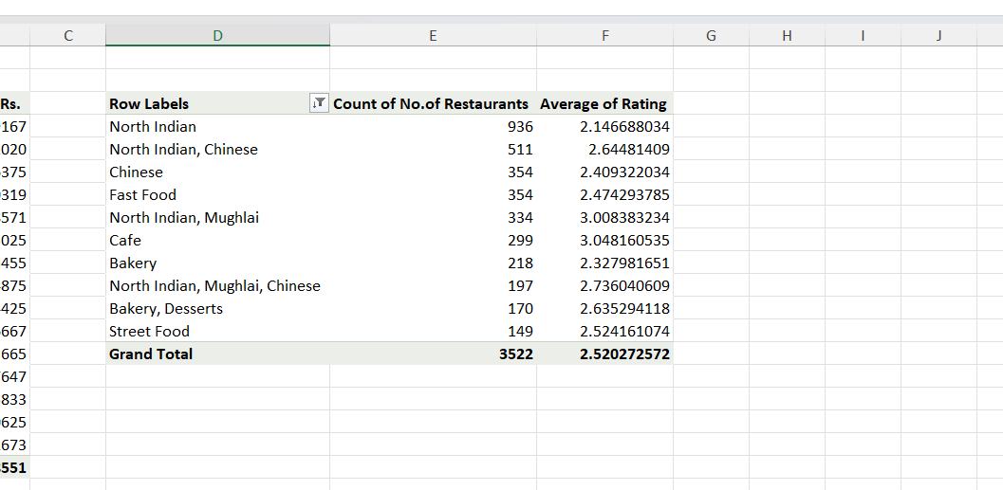

The choice of cuisine may affect the restaurant ratings and I have taken top 10 cuisines from the dataset for better selection of cuisines. Here are some possible insights:

* **North Indian cuisine** is popular, but may be oversaturated: With 936 restaurants, North Indian cuisine may be too common, leading to a lack of uniqueness and differentiation among these restaurants. This could lead to lower ratings as customers seek out more authentic or innovative experiences.
* **Chinese cuisine** has potential for growth: With 354 restaurants, Chinese cuisine has less market saturation compared to North Indian cuisine. This could indicate an opportunity for new restaurants to enter the market and attract customers seeking a different type of cuisine.
* **Fast Food and Cafe cuisines** may appeal to a broader audience: Combination of Fast Food and Cafe cuisines have a relatively high number of restaurants (354 and 299, respectively). Fast Food is most popular among teenagers. These cuisines may appeal to a broader audience, including those who prefer quick and casual dining options.
* **Specialized cuisines like Mughlai and Bakery** may have a niche audience: Cuisines like Mughlai (334) and Bakery (218) may appeal to a niche audience with specific tastes or preferences. These restaurants may benefit from targeting their marketing efforts towards this audience.

To get better feedback, it may be worth considering opening new restaurants that cater to underserved cuisines or niches, such as: Chinese cuisine with a unique twist (e.g., fusion or modern interpretations), Specialty cuisines like Mughlai or Bakery, Innovative takes on traditional cuisines like North Indian.

By focusing on these cuisines, we can differentiate the restaurant from the competition and attract customers seeking something new and exciting.

1. According to our current data, should we go for online delivery and table booking? Does that affect the customer’s ratings?

**Reference:**

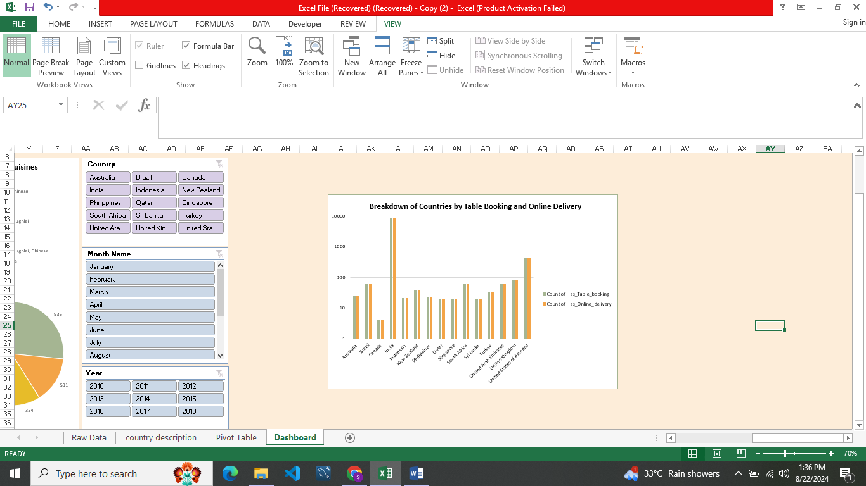

* There are both pros and cons for table booking and online delivery.
* For online delivery, it provide convenient to customers as food is reached to door step and also increase sales for our restaurant as working professionals prefer online delivery only. But when come to cons, higher costs and delivery staff should be kept.
* For table booking, it help restaurant to be full and have customer interaction. While come to cons, there may be some restaurants where capacity of seats must be limited for their restaurants for table booking and for heavy customers transaction bills will be hectic to do.

1. Should the team keep the rate of cuisines higher? Will that affect the feedback? According to our data are the rates of cuisines and ratings, correlated?

**Reference:**

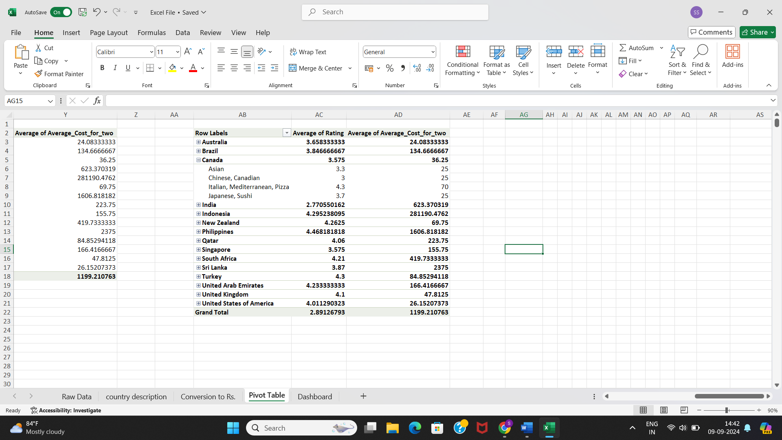

* From the data, we can see that the average rating of cuisines is around 4.0, with a range from 1.0 to 4.9. The average cost of two people for a meal is around 500, with a range from 10 to 8000.
* Looking at the correlation between the rate of cuisines and the feedback ratings, we can see that:
* For cuisines with high ratings (4.5-5.0), the average cost is around 140.00 - 160.00.
* For cuisines with medium ratings (3.5-4.4), the average cost is around 60.00 - 120.00.
* For cuisines with low ratings (2.5-3.4), the average cost is around 20.00 - 50.00 .
* The average rating for each country ranges from 2.77 to 4.33 .
* This suggests that there is a positive correlation between the rate of cuisines and the feedback ratings, meaning that higher-rated cuisines tend to have higher average costs. This is likely due to the fact that higher-rated cuisines may offer more unique or high-quality dining experiences, which may be reflected in their prices.
* However, it's also worth noting that there is some variation in this relationship, and that there may be other factors that influence the cost of a meal beyond just the rating of the cuisine. For example, the type of cuisine, the location, and the size of the restaurant may all play a role in determining the cost of a meal.
* Therefore, if we want to keep the rate of cuisines higher, we may need to consider other factors beyond just the rating of the cuisine itself, such as offering unique or high-quality dining experiences, or targeting a specific demographic or market segment.

1. What is the distribution of the number of restaurants of different price ranges in all the countries?

**Reference:**

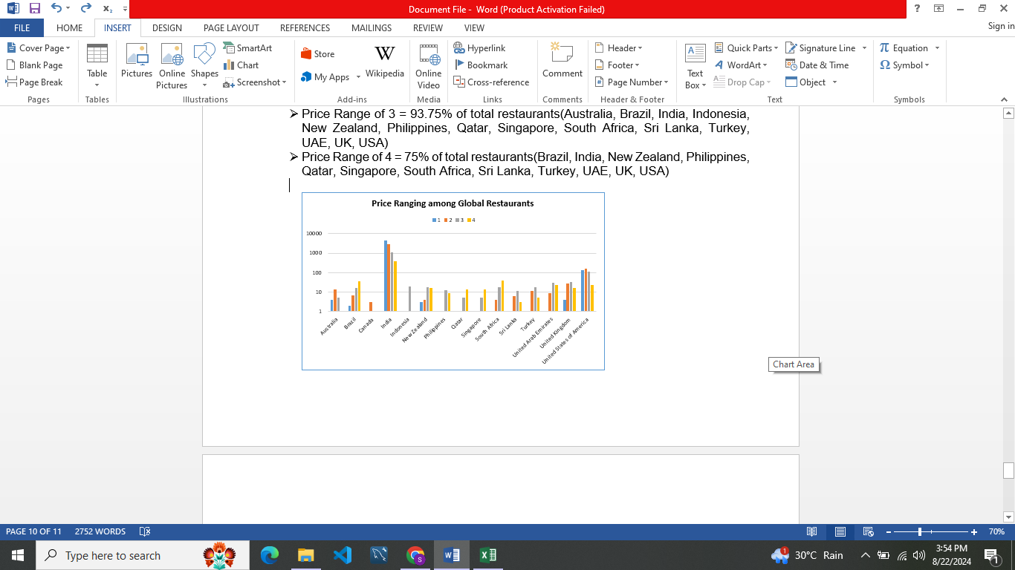

* Here's a rough visualization of the distribution of restaurants by price range in various countries:
* Under price range of 1 = 37.5% of total restaurants( Australia, Brazil, India, New Zealand, UK, USA)
* Price range of 2 = 68.75% of total restaurants(Australia, Brazil, Canada, India, New Zealand, South Africa, Sri Lanka, Turkey, UAE, UK, USA)
* Price Range of 3 = 93.75% of total restaurants(Australia, Brazil, India, Indonesia, New Zealand, Philippines, Qatar, Singapore, South Africa, Sri Lanka, Turkey, UAE, UK, USA)
* Price Range of 4 = 75% of total restaurants(Brazil, India, New Zealand, Philippines, Qatar, Singapore, South Africa, Sri Lanka, Turkey, UAE, UK, USA)

1. Explain your approach in brief for suggesting countries/cities in order to open new restaurants, if the objective and subjective questions would have not been given to assist you.

* If I didn't have the objective and subjective questions to guide my suggestions, I would take few approaches to identify countries and cities for opening new restaurants. Here's a brief outline of my approach:
* I would like to analyze the trends and growths around the globe such as GDP growth, consumer spending patterns so that it help me to identify countries and cities with growing economies and increasing consumer demand.
* I would research on the local cuisine, food preferences of each country and city to identify opportunities to introduce unique flavors, cuisines, or dining concepts that cater to local tastes.
* I would examine the demographics of each country and city, including population size, age distribution to identify areas with a high potential for opening a restaurant.